Greg Vannoni
INFO 636
Assignment 2A

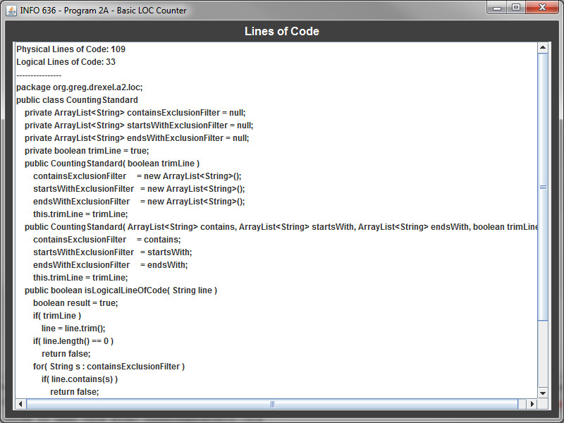
Figure 1. Screenshot of Assignment 2A

Displays the number of physical LOC and logical LOC along with the logical LOC visually to the user.
Physical & Logical LOC Results

Program 1B
org.greg.drexel.b1.Main.java
- Physical LOC: 109
- Logical LOC: 32

org.greg.drexel.b1.gui.MainFrame.java
- Physical LOC: 296
- Logical LOC: 90

org.greg.drexel.b1.types.FileModeType.java
- Physical LOC: 32
- Logical LOC: 10

org.greg.drexel.b1.io.MyFileReader.java
- Physical LOC: 65
- Logical LOC: 13

org.greg.drexel.b1.io.MyFileWriter.java
- Physical LOC: 64
- Logical LOC: 12

Program 2A
org.greg.drexel.a2.loc.CountingStandard.java (Added from 1B)
- Physical LOC: 109
- Logical LOC: 33 (All 33 LOC added)

org.greg.drexel.a2.loc.LOCCounter.java (Added from 1B)
- Physical LOC: 87
- Logical LOC: 20 (All 20 LOC added)

org.greg.drexel.b1.Main.java (Modified from 1B)
- Physical LOC: 108
- Logical LOC: 41 (1B: 32, so 41-32 = 9 LOC added)

org.greg.drexel.b1.gui.MainFrame.java (Modified from 1B)
- Physical LOC: 174
- Logical LOC: 55 (1B: 90, so 90-55 = 35 LOC deleted)

org.greg.drexel.b1.io.MyFileReader.java (Untouched from 1B)
- Physical LOC: 65
- Logical LOC: 13 (Same LOC from 1B, untouched code)

org.greg.drexel.b1.io.MyFileWriter.java (Modified from 1B)
- Physical LOC: 64
- Logical LOC: 12 (Same LOC from 1B, only modified LOC)

Note: Completely removed org.greg.drexel.b1.types.FileModeType.java from 1B (10 LOC deleted)

Totals
Program 1B
- Physical LOC: 626
- Logical LOC: 157
Program 2A
- Physical LOC: 607
- Logical LOC: 174

I really wanted to focus on added a nice structure for counting lines of code in the future. Most of the code from Program 1B was reused in Program 2A and the code I wrote in 2A may also help me further down the road in other assignments.
Table C16 Time Recording Log

Student |  | Greg Vannoni |  |  |  |  | Date | 1/20/10
Instructor |  | Glenn Booker |  |  |  |  | Program # | 2A
Date | Start | Stop | Interruption  Time | Delta  Time | Phase | Comments
1/20 | 11:16p | 12:36a | 10 | 10 | PLN | Laundry
1/21 | 12:00a | 12:37a |  | 37 | DES | Mainly worked on Counting/Coding Standard
1/21 | 5:20p | 5:40p | 5 | 15 | CODE | Snack
1/21 | 7:00p | 9:10p |  | 130 | CODE | Completed coding and commenting
1/21 | 9:11p | 9:12p |  | 1 | COMP | Compiled successfully
1/22 | 7:00a | 7:30a |  | 30 | TEST
1/22 | 7:31a | 7:34a |  | 3 | CODE | Fix Defects from testing
1/22 | 7:35a | 7:36a |  | 1 | COMP | Compiled successfully
1/22 | 7:37a | 7:47a |  | 10 | PM
1/22 | 6:15p | 7:15p |  | 60 | PM
1/23 | 10:00a | 11:50a |  | 110 | PM

Table C18 Defect Recording Log
Defect Types
10 Documentation 60 Checking
20 Syntax 70 Data
30 Build, Package 80 Function
40 Assignment 90 System
50 Interface 100 Environment
Student |  |  |  | Greg Vannoni |  |  |  |  |  |  |  | Date |  | 1/20/10
Instructor |  |  |  | Glenn Booker |  |  |  |  |  |  |  | Program # |  | 2A
Date |  | Number |  |  |  | Type |  | Inject |  | Remove |  |  | Fix Time |  | Fix Defect
1/20 |  | 1 |  |  |  | 10 |  | planning |  | code |  |  | 10
Description: |  |  | Didn't plan to write source code into a file and then read it back in to determine logical lines of code. Modified code to write to file (instead of just read from ArrayList)
Date |  | Number |  |  |  | Type |  | Inject |  | Remove |  |  | Fix Time |  | Fix Defect
1/20 |  | 2 |  |  |  | 50 |  | planning |  | code |  |  | 6
Description: |  |  | Because application was reused from assignment 1B, had to rename interface window and buttons to be meaningful for this program
Date |  | Number |  |  |  | Type |  | Inject |  | Remove |  |  | Fix Time |  | Fix Defect
1/22 |  | 3 |  |  |  | 20 |  | design |  | code |  |  | 3
Description: |  |  | Didn't design system to have larger window needed to output logical line of code file contents. Had to make window larger and use a JScrollPane so a user can scroll up and down, left and right if output is too large.
Date |  | Number |  |  |  | Type |  | Inject |  | Remove |  |  | Fix Time |  | Fix Defect
1/22 |  | 4 |  |  |  | 40 |  | design |  | test |  |  | 3
Description: |  |  | Forgot to design program without using ArrayList<Double> from program 1B and use ArrayList<String> instead.
Date |  | Number |  |  |  | Type |  | Inject |  | Remove |  |  | Fix Time |  | Fix Defect
Description:
Date |  | Number |  |  |  | Type |  | Inject |  | Remove |  |  | Fix Time |  | Fix Defect
Description:
Date |  | Number |  |  |  | Type |  | Inject |  | Remove |  |  | Fix Time |  | Fix Defect
Description:
Date |  | Number |  |  |  | Type |  | Inject |  | Remove |  |  | Fix Time |  | Fix Defect
Description:
Table C25 PSP0.1 Project Plan Summary

Student | Greg Vannoni | Date | 1/22/10
Program | LOC Counter | Program # | 2A
Instructor | Glenn Booker | Language | Java

Program Size (LOC) | Plan |  |  |  | Actual |  |  |  | To Date
Base(B) |  |  |  |  | 157 (from Program 1B)
 |  |  |  |  | (Measured)
Deleted (D) |  |  |  |  | 45
 |  |  |  |  | (Counted)
Modified (M) |  |  |  |  | 30
 |  |  |  |  | (Counted)
Added (A) |  |  |  |  | 174-157+45-0 = 62
 |  |  |  |  | (T-B+D-R)
Reused (R) |  |  |  |  | 0 |  |  |  | 0
 |  |  |  |  | (Counted)
Total New & Changed (N) | 60 |  |  |  | 62+30 = 92 |  |  |  | 92
 |  |  |  |  | (A+M)
Total LOC (T) |  |  |  |  | 174 |  |  |  | 174
 |  |  |  |  | (Measured)
Total New Reused Reusable |  |  |  |  | 50 |  |  |  | 50
Time in Phase (min.) | Plan |  | Actual |  |  |  | To Date |  |  |  | To Date %
Planning | 10 |  | 10 |  |  |  | 11 |  |  |  | 1.86%
Design | 30 |  | 37 |  |  |  | 46 |  |  |  | 7.77%
Code | 60 |  | 148 |  |  |  | 279 |  |  |  | 47.13%
Compile | 1 |  | 1 |  |  |  | 3 |  |  |  | 0.51%
Test | 20 |  | 30 |  |  |  | 63 |  |  |  | 10.64%
Postmortem | 100 |  | 180 |  |  |  | 190 |  |  |  | 32.09%
Total | 221 |  | 406 |  |  |  | 592 |  |  |  | 100%
Defects Injected |  |  | Actual |  |  |  | To Date |  |  |  | To Date %
Planning |  |  | 2 |  |  |  | 4 |  |  |  | 44.44%
Design |  |  | 2 |  |  |  | 2 |  |  |  | 22.22%
Code |  |  | 0 |  |  |  | 3 |  |  |  | 33.33%
Compile |  |  | 0 |  |  |  | 0 |  |  |  | 0
Test |  |  | 0 |  |  |  | 0 |  |  |  | 0
Total Development |  |  | 4 |  |  |  | 9 |  |  |  | 100%
Defects Removed |  |  | Actual |  |  |  | To Date |  |  |  | To Date %
Planning |  |  | 0 |  |  |  | 0 |  |  |  | 0
Design |  |  | 0 |  |  |  | 0 |  |  |  | 0
Code |  |  | 3 |  |  |  | 4 |  |  |  | 44.44%
Compile |  |  | 0 |  |  |  | 0 |  |  |  | 0
Test |  |  | 1 |  |  |  | 5 |  |  |  | 55.55%
Total Development |  |  | 4 |  |  |  | 9 |  |  |  | 100%
After Development |  |  | 0 |  |  |  | 0

Table C27 Process Improvement Proposal (PIP)

Student | Greg Vannoni |  | Date | 1/22/10
Instructor | Glenn Booker |  | Program # | 2A
Process | PSP0.1 | Elements

PIP Number
 |  | Problem Description
1 |  | Hard to determine add/removed/modified code for PSP forms. I don't like
 |  | counting/commenting each line I add/modify/delete every time I code.
2
PROPOSAL
PIP # |  | Proposal Description
1 |  | Using Google Code, perform "diffs" on previous code and new code,
 |  | delete code will be red, modified code is yellow and added code is green.
Notes and Comments:
 |  | Learned that counting LOC is a little different than I first thought. I had
 |  | to make decisions to not count certain things (like Java imports) that I
 |  | haven't had to think about before.

R1 LOC Counting Standard
(Similar to Table 4.1)

Student | Greg Vannoni | Date | 1/21/10
Language | Java | Version | 2A
Instructor | Glenn Booker

Count Type | Type | Comments
Physical / Logical | Logical
Statement Type | Included | Comments
Executable | yes
Non-executable:
Declarations | yes
Compiler Directives | no | N/A with Java
Comments | no | Never count comments
On Separate Lines | no
With code | no | If on same line as uncommented code, the code will be counted
In Blocks | no
Blanks | no
Clarifications
Nulls | yes | e.g., continue, break
Empty Statements | yes | ";;", lone ;'s, etc.
Block Start | yes | e.g., {, count keywords case, do, if, else if, while
Block End | yes | e.g., }
Conditionals | yes | &&, ||, ==, etc.
Result clauses | yes | e.g., else
Keywords | yes | interface, implementation, class definition
Labels | yes | on separate lines (not common in Java)
Imports | no | Do not count imports as there can be different styles which can cause an inconsistent LOC count

R2 Coding Standard
(Similar to Table C29)

Student | Greg Vannoni | Date | 1/21/10
Language | Java | Version | 2A
Instructor | Glenn Booker

Item | Example or Comment
Comments
File Header | Begin all programs with descriptive header  /**  * @author Greg Vannoni  * @class INFO 636  * Purpose: Display dialog and input boxes to the user in order to:  * 1. Obtain input to write (Real numbers) into a file  * 2. Display the contents of a file (with Real numbers)  *  * @version 1.0  * Notes:  *  *  */
Function Header | /**  * Method: displayError<br/>  * Displays an error dialog box to the user.  *  * @param message - The message to display to the user  * @param title - The title of the dialog box  */
Section header | N/A
Other Blocks | // Setup all of the panels around the JList to be DARK_GRAY for consistency (and good looks).  fillerPanelEast.setBackground( Color.DARK_GRAY );  fillerPanelWest.setBackground( Color.DARK_GRAY );  fillerPanelSouth.setBackground( Color.DARK_GRAY );  myLabelPanel.setBackground( Color.DARK_GRAY );
On lines of code | JPanel panel = new JPanel( new BorderLayout(3, 0) ); //Pad horizontally by 3, 0 on the vertical
Statements
Number per line | One statement per line  result = Double.parseDouble( input );
Declarations | One declaration per line  JPanel myLabelPanel = new JPanel();
Spacing
Blank lines | - Use freely to make code easier to read so source doesn't look crowded.  - Add two spaces after each method for readability.
Margins | Place package name on the first line of the source code.  package org.greg.drexel.b1.gui;
Indenting | Open and close braces should be on lines by themselves and aligned with each other.  Use spaces instead of tabs  Use 4 spaces for indention  public Integer getQuantityOfNumbers()  {  Integer quantity = null;  String input = JOptionPane.showInputDialog( "How many numbers are you going to record?" );  if( input == null )  {  // User pressed cancel button, just exit for now  System.exit(-6);  }  try  {  quantity = Integer.parseInt( input );  }  catch( NumberFormatException nfe )  {  // User didn't enter a number (jerk!), return them to the input screen.  displayWarning( "You didn't enter in a number! Try again.", "Number input error" );  return getQuantityOfNumbers();  }  return quantity;  }
Names
Choosing values | Variable names should be long enough to accurately determine the use
Capitalization | Name should start with a lowercase letter and have capital letters whenever another word is added to the variable name.  getSingleNumberInput( i+1 );  or  ArrayList<String> fileContents = new ArrayList<String>();
Dash or underscore | When using final ("declare") variables, use all capitals and underscores where spaces would normally be.  private final String WINDOW_TITLE = "INFO 636 - Program 2A - Basic LOC Counter";  private final Dimension DEFAULT_WINDOW_SIZE = new Dimension(500,500);

